Caseload Tool
PATH: Student Information > Special Ed > Caseload
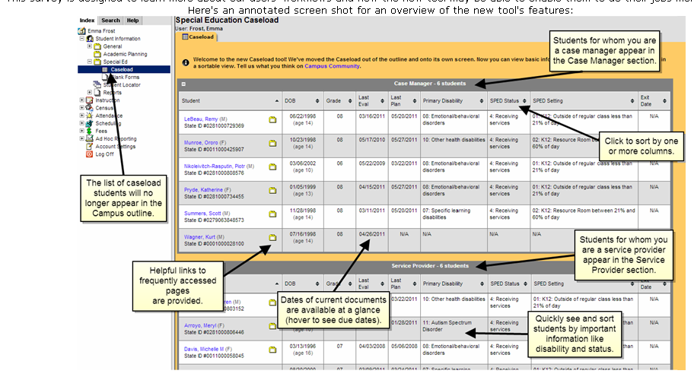
Previously, the Caseload appeared as a list of students in the Index. The new Caseload tool, accessed by clicking on Caseload (new!) in the index, lists students in the user's caseload, for both Case Manager and Service Provider roles. The list of students in the index will appear by clicking the + icon next to the Caseload tool. Useful features of this tool include:
- Sortable columns in each table that include important dates for locked documents and special education information for each student. (special ed only)
- Additional date information available when hovering over Last Eval and Last Plan fields. (special ed only)
- Students' names link to the Summary tab in Special Ed.
- Folder icon links to the student's Documents tab.
The student list in the Caseload tool is determined by active Team Memberships (those without an End Date or those that have an End Date that is after the current date), as well as students for whom the user is indicated as a Service Provider in an active Document.

