8/17/09

I am e-mailing to let everyone know that the IEP is now up and going in Infinite Campus.  The IEP needs to be entered into Infinite Campus and no longer entered onto an IEP state form and uploaded to Infinite Campus.  Please be sure to pay attention and address each of the sections below when entering data on the IEP.  These two sections are a very important part of the IEP and is used for Childcount.

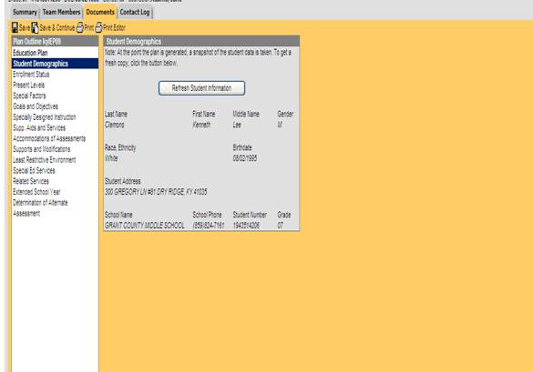

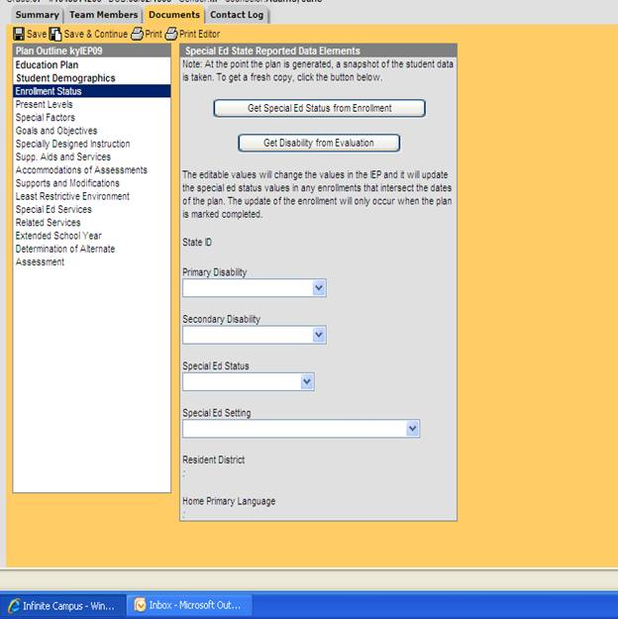

If you have any questions, please let me know.

Thanks,

Tonya Young

Special Education

Grant County Schools