8/17/09

I am sending this e-mail to advise and address of information in 2  sections of the IEP in Infinite Campus.

The first Section is SDI.  You can see the section shown below.  There is to be  **NO** information entered into this section. **ALL** SDI is to be entered under each goal entered on the IEP as you can see in the second screen shot.

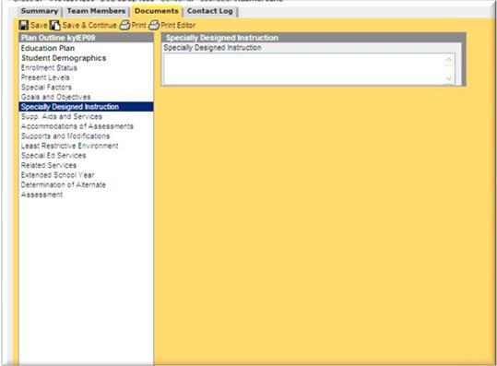

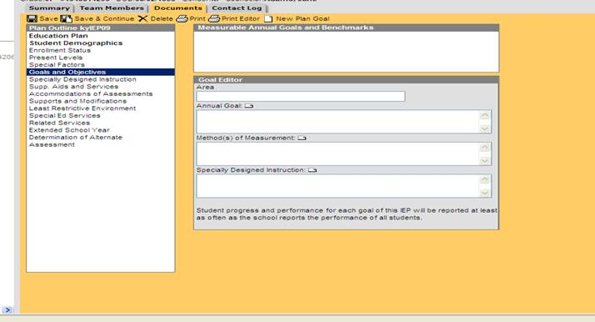

The other section to be addressed is the Special Education Services Section of the IEP (SPED Services Editor)  **AT THE PRESENT TIME UNTIL NOTIFIED DIFFERENTLY THE SPECIAL EDUCATION SERVICES IS THE ONLY  CHOICE TO BE USED FROM THE DROP DOWN.**

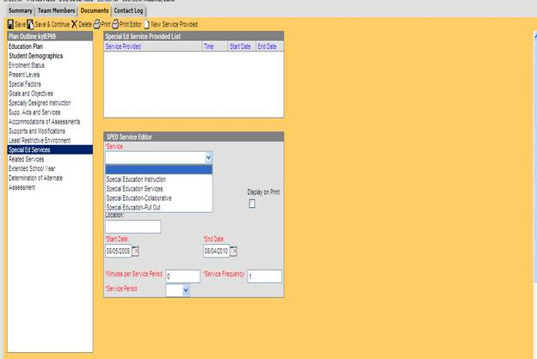

If you have any questions, please let me know.

Thanks,

Tonya Young

Special Education

Grant County Schools