**1. Infinite Campus Issue: Students Records Transfer**

The import of the editor based conference summary is not working (Page 76-Data Standards)

Projected Fix for this issue is end of October

Current Work Around:

*Import Conference Summary as a PDF

*Create Editor Based Conference Summary

*Enter data necessary for child count ---Enter correct evaluation date (date of report),

eligibility date, disability, and the ARC date needs to be the date that the student

transferred into the district or the conference summary form creation date.

Data will need to be entered stating the Conference Summary was created for

reporting purposes only. (See Revised Notes below that were supplied by KDE in

2011-2012)

If you have an incoming student who does not have a KYESR or Editor Based Locked Conference Summary in I.C. then you will need to create a new Conference Summary to input the students Evaluation and Eligibility Determination Date into an editor based Conference Summary. I would advise entering the ARC meeting date the date the student transferred into district/conference summary form creation date. The Evaluation date entered as the actual date in which the previous district did the Evaluation (note: this will then store the document in the date of the year of Evaluation on the display screen). I would recommend that you add these dates to the Conference Summary that you create when you meet to accept the student IEP and discuss eligibility.

If the KYESR was not completed at the appropriate time and an *Eligibility Determination Date* is not recorded OR the KYESR is not transferring through the Student Records Transfer process as editor based, the district must do the following to ensure that the student’s Re-Evaluation Due Date is calculated correctly:

1. Create an editor-based **Conference Summary**
2. Enter the *Evaluation Date* as the actual date in which the student’s last evaluation or re-evaluation was conducted.
3. Enter the *ARC Date* as the date the student transferred into the district/conference summary form creation date.
4. Select the *Purpose of the Meeting* as Eligibility/Continued Eligibility

Description: ARC Date: Enter in the original date of the eligibility determination meeting.Description: Eligibility Determination Date: this is a read only field populated from the eligibility determination date entered on the Eligibility/Continued Eligibility editor.Description: Evaluation Dates is the date of the Evaluation Report. 
The Conference Summary once saved will display under Conference Summaries/Evaluations in the appropriate year based on the Evaluation Date entered.
Evaluation Date cannot be left blank.
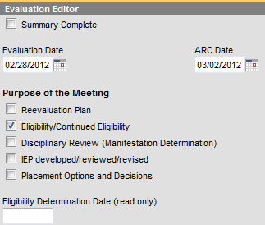

**ARC Date:** Enter the date the student transferred into the district/ conference summary creation date.

NOTE: The document once locked and saved will display on the documents list based on the date entered

1. Save and Continue through the required editors of the Conference Summary
   1. **Student Demographics** Editor – Click *Refresh Student Information* button
   2. **Basis of ARC** Editor – select the *Other Data* checkbox and enter the following statement in the Specify textbox:

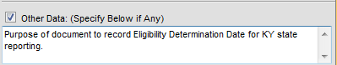

* 1. **Parent Concerns and Input** Editor – enter the same statement as above in the textbox:

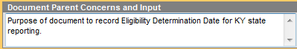

1. **Eligibility/Continued Eligibility** editor -
   1. Enter the original *Date of Eligibility Determination* *Date*
      1. This date will auto-populate as a read only field on the **ARC Header** Editor
      2. This date will calculate student’s *Re-Evaluation Due Date* on the *IDEA December 1 Child Count* and other reports within Infinite Campus.
   2. Select student’s Primary Disability from the drop list
      1. The Primary Disability will write to the student’s KYIEP using the *Get Disability from Evaluation* button
   3. Include in the *Notes* textbox a **detailed** statement the sole purpose the Conference Summary is to enter the *Eligibility Determination Date* for state reporting purposes.

Description: Notes: Include a detailed statement to inform future readers that Conference Summary is for the sole purpose of entering in Eligibility Determination Date for state reporting purposes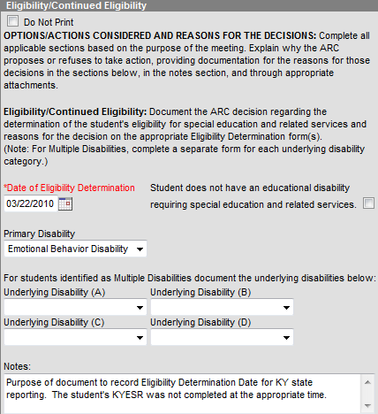

1. **Other Factors** editor – select the *None Identified* checkbox:

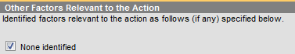

1. **Admissions and Release Committee** editor – Enter the name of the person completing the document in the required field:

Description: cid:image030.png@01CD0CF4.0D9F0010

1. Save each editor after completing section
2. Lock document

**NOTE: The above will always be the case if a student moves in/transfers from a state other than Kentucky.**

**2. Infinite Campus Enrollment Tab Information Rolling Forward Issue**

Any 2011-2012 special education updates to the enrollment tab that took place after the school’s

initial roll forward during the 2011-2012 school year didn’t roll into the 2012-2013 special education

enrollment tab. (Note: Tonya Young has tried to run reports to find these issues and correct them.

If you find any of these instances please update the 2012-2013 special education enrollment tab

accordingly.) (KDE and Infinite Campus are working on a way to prevent this from happening this

year.)

**3. Special Education Flag**

The special education flag is now generated from the information under the special education

enrollment tab. KDE and Infinite Campus are working for this to be changed. The special

education flag will read off of the IEP document. Districts are not responsible and should not

manually update this section. This section automatically updates each evening.

**4. Special Education Enrollment Tab**

The primary disability and setting section is IEP controlled.

Pre-Referred and Referred can now be changed to Not Eligible.

A student can be made inactive to cover being withdrawn.

**(Please see instructions below supplied by KDE in regards to the necessary steps to follow**

**when a special education student exits by transferring to regular education and exits by**

**withdrawing from the school district)**

The purpose of this Information is to detail the procedures that should be followed when 1) a student is released from special education services when the ARC has determined the child no longer meets the eligibility requirements or the parent/child revokes consent for services OR 2) the student moves out of your district.

***Student released from services (no longer eligible or consent revoked) and student remains in your district***

➢ General | Enrollment Tab | Special Education section

• Select the Special Ed Exit Reason

• Enter the Special Ed Exit Date

• Change the Special Ed Status to either Inactive or Eligible, Parents Refused, whichever is appropriate

➢ General | Transportation Tab

• End date the Transportation of T5: Special Transported, if applicable

➢ Special Education | Documents Tab:

• Unlock student’s current IEP

• Education Plan Editor - Change the IEP End Date to the date services ended

• Enrollment Status Editor - Change the student Special Ed Status to Inactive or Eligible, Parents Refused, whichever is appropriate

• Special Ed Service Editor – Change End Date for each service to the date services ended

• Related Services Editor - Change End Date for each service to the date services ended

• Lock IEP and save

➢ Special Education | Team Members Tab

• End date each Team Member listed for student to the date services ended •

***Student moves from the district or otherwise withdraws***

➢ General | Enrollment Tab | Special Education section

• Select the Special Ed Exit Reason

• Enter the Special Ed Exit Date

• Change the Special Ed Status to either Inactive or Eligible, Parents Refused, whichever is appropriate

➢ General | Transportation Tab

• End date the Transportation of T5: Special Transported, if applicable.

➢ Special Education | Team Members Tab

• End date each Team Member listed for student to the date services ended

***NOTE:*** When a student moves from the district or otherwise withdraws, the IEP should **NOT** be unlocked and end dated marked as *Inactive* on the **IEP | Enrollment Status** editor. This should NOT be done as it will cause a student who enrolls in another district and/or returns to your district not to have a current IEP on record.

**5. Infinite Campus Sequence**

Conference Summary ➢ IEP ➢ Enrollment Tab

NOTE: This means the conference summary has to be started, completed, and locked before IEP>

**6. IEP (**Data Standards Pages25 -37)

When creating an IEP:

Get Special Ed Status from Enrollment

Do not use the icon

Get Disability from Evaluation

Use the icon

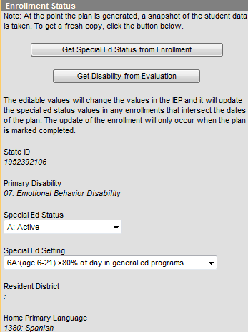

**Caution: When selecting the setting for a student that is 5 years old you have to look at the date the IEP is being created and his age on December 1st and choose the LRE accordingly. In the drop down for Special Ed Setting you will see the setting for the 3-5 year olds and the 6-21 year olds.**

**7. IEP Related Services**

Hearing Impaired and Vision Impaired is going away under the related services section of the

IEP and will have to be entered as Special Education Services

**8. Conference Summary (**Data Standards Pages 38 -53)

**Evaluation Date:** Enter the date of the Evaluation or Written Assessment Report Date. This field auto-populates with the most recently entered Evaluation Date. This field is required and can be edited to reflect the new Date of Written the Assessment Report, if applicable. **This date needs to be checked on each conference summary to verify that the correct report date is entered into this field.**

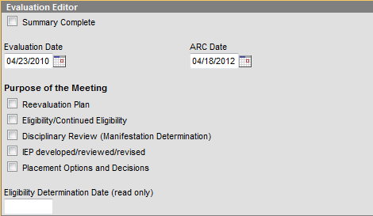

Please note that the Conference Summary once saved will display under Conference Summaries/Evaluations in the appropriate year based on the ARC Date entered.

The Evaluation Date will auto populate with the most recently entered Evaluation Date. This field can be edited. The field is required.

Eligibility Determination Date: this is a read only field populated from the eligibility determination date entered on the Eligibility/Continued Eligibility editor, if appropriate.

**Date of Eligibility Determination:** Enter month, day and year of the last date that eligibility for

services were determined by the ARC. **This date needs to be checked on each conference**

**summary to verify that the correct report date is entered into this field.**

* This date will auto populate to the students most recent Date of Eligibility Determination regardless of the purpose selected.
* This date will populate as a Read Only field on the ARC Header Editor.
* This date will also calculate the Reevaluation Date of the student on various reports within Infinite Campus and the *IDEA December 1 Child Count*.

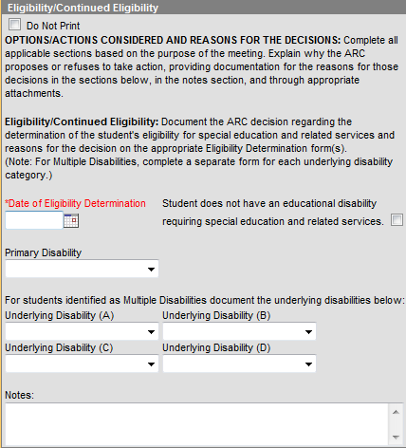

**Primary Disability:** The Primary Disability will auto populate with the most recent P.D. regardless of the purpose of the meeting. From the drop list, select the appropriate category of disability for student. **This section will need to be checked to verify that each conference summary shows the correct disability. This is important so it feeds to the IEP with the correct disability and is correct for child count.**

*If Multiple Disabilities selected as Primary Disability at least two Underlying Disabilities must be selected*

* *The students Primary Disability will auto populate from the students previous Conference Summary regardless of the purpose selected.*

NOTE: Data elements in this area should be completed based on appropriate disability eligibility form. Once document saved and locked any subsequent KYIEP, KY Private School Plans and fields will populate with selection.

A selection from the Primary Disability drop list **OR** the checkbox of Student does not have an educational disability...MUST be made if Eligibility/Continued Eligibility is selected as Purpose of Meeting.

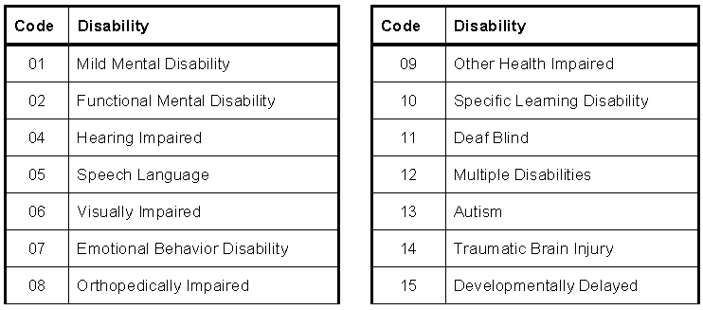

NOTE: The location of this field is the data owner of Primary Disability and will populate the IDEA December 1 Child Count

The ‘Do not Print’ checkbox should be selected when the purpose of the meeting does not include ‘Eligibility/Continued Eligibility’ **AND** the user prefers the section to not print.

**9. Create Documents ---Simple Forms**

The forms have been into sequence in alphabetical order. The accommodations form loaded by Infinite Campus and KDE has been hidden and the Grant County Accommodations form is the only Accommodations form available for entry.