Indicator 13

Kentucky Transition Requirements

Kentucky Continuous Monitoring Process

2011- 2012 School Year

**Indicator 13 Transition Requirements at a Glance**

**Transition Services 707 KAR 1:320 Section 7 (SPP Indicator 13)**

|  |  |  |
| --- | --- | --- |
| **KCMP**  **Indicator 13** | **Y N**  **Y N** | **Note for items 49a-49i: Complete this section for students who are 16 years of age or older.**  **49a. The IEP includes appropriate measurable postsecondary goals related to**   * **training or education, and** * **employment, and** * ***when appropriate*, independent living skills.**   **49b. The IEP includes transition services that will reasonably enable the child to reach the**  **postsecondary goals.** |
|  | **Y N** | **49c. For transition services likely to be provided or paid for by another agency, the other**  **agency is invited to send a representative, if appropriate.** |
|  | **Y N** | |  | | --- | | **49d. If an agency was invited to send a representative, signed Consent for**  **Outside Agency Invitation is included.** | |
|  | **Y N** | **49e. As a transition service, the child has a multi-year course of study as outlined in the**  **Individual Learning (Graduation) Plan.** |
|  | **Y N** | **49f. Annual goal(s) included in the IEP are related to the transition service needs.** |
| **Y N NA**  **Y N NA** | **Y N**  **Y N**  **Y N**  **49.**  **50.** | **49g. Measurable postsecondary goals are based on age-appropriate transition**  **assessment.**  **49h. The child is invited to the ARC meeting where transition services are discussed.**  **49i. The measurable postsecondary goals are updated annually.**  **For students who have reached the age of 16 and older, all the above (a-i) requirements are met: (*Mark Y if all the requirements listed above are Y; Mark N if one or more of the requirements listed above are N. Mark this item “NA” if the child is not yet 16 as of the date of this record review).***  **By the student’s 16th birthday, all of the requirements above are met. (*Mark this item “NA” if the student is 17 or older).*** |

**Transition Services - 707 KAR 1:320 Section 7**

**Item 49a**

**Note for items 49a-49i: Complete this section for students who are 16 years of age or older.**

**Look for**: IEP, Measurable Postsecondary Goals.

**Directions:**

* Mark “YES” if documentation includes postsecondary goals to cover two (2) areas, education/training and employment, and a third goal as needed for independent living.
* Mark 49a “YES” only if 1 and 2 (and 3 if appropriate) are yes.

**Note**: Postsecondary goals must be measurable and intended to occur after the student graduates from high school.

|  |  |  |  |
| --- | --- | --- | --- |
|  | **Yes** | **No** | **NA** |
| 49a. The IEP includes appropriate measurable postsecondary goals related to |  |  |  |
| 1. training or education |  |  |  |
| 1. employment |  |  |  |
| 1. when appropriate, independent living skills |  |  |  |

**Examples and Documentation on IEP Form**

49a. The IEP includes appropriate measurable postsecondary goals related to

* training or education, and
* employment, and
* *when appropriate*, independent living skills.

Postsecondary goals are to be documented by the ARC on the IEP form. On the last page of the IEP, the ARC uses the section where the postsecondary goal(s) are to be documented titled “Postsecondary Goal(s).” A copy of that section is pasted below with an example added.



To document in Infinite Campus, use the 16+ IEP, go to the “Transition Services (16)” editor. Type the postsecondary goal statement(s) under the heading “Postsecondary Goal(s) Related to Education/Training, Employment, and if needed, Independent Living:”

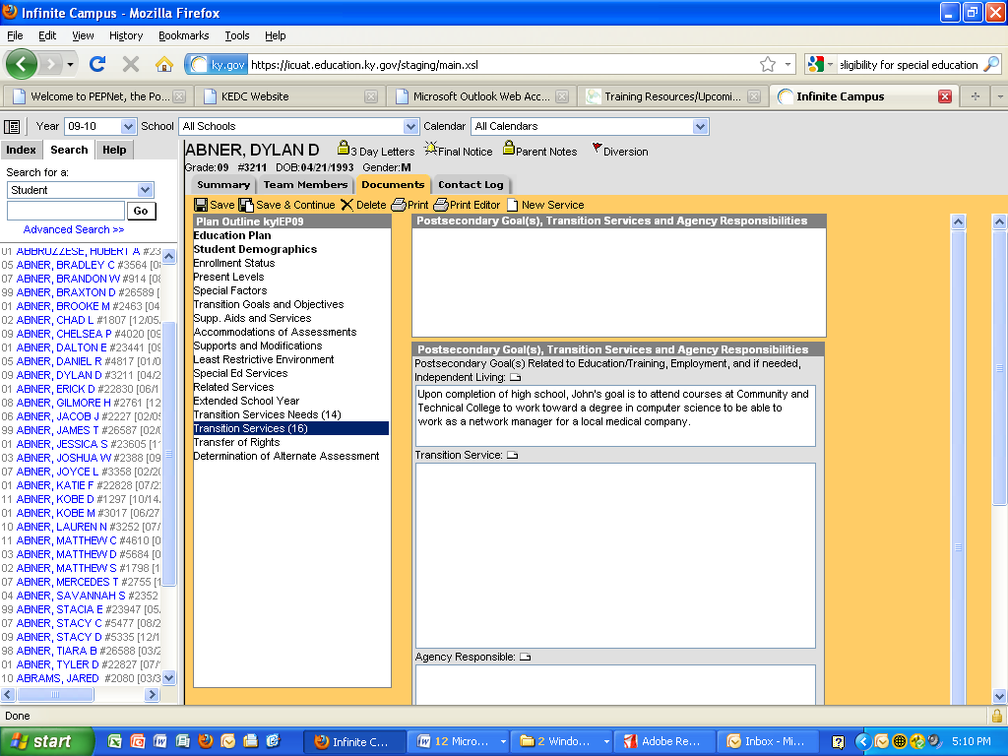

More Examples of Postsecondary Goals for the required areas of Training/Education and Employment combined:

* John’s goal for after graduation is to enroll in courses at the Community and Technical College to work in the field of medical technology.
* Jamarreo’s goal for after graduation is to complete welding courses at Jefferson Community College and become a self-employed welder.
* After graduation, Rolanda will receive job development services from vocational rehabilitation or a community rehabilitation program and will participate in technologically supported self-employment or volunteer work.
* After high school, Jeremy will improve his social, self-advocacy, and self-care skills by attending instruction at a center-based adult program and be employed part-time in a local business with supports.
* After high school, Jodi’s goal is to improve job skills through a job training program to be able to work in a retail setting.
* After graduation, Glenn’s goal is to continue on-the-job training at his family’s business.
* After graduating, Paulo’s goal is to participate in training to improve his work skills in his job at a grocery store.
* Jason will enroll in a four-year college to obtain his undergraduate degree in history and education, to become a high school social studies teacher.

In addition to the required areas of training/education, some students will also need a postsecondary goal for independent living skills. If so, these students would have postsecondary goals to cover all three areas, training/education, employment, and independent living skills.

Examples of Postsecondary Goals for Independent Living:

* Upon completion of high school, Jeremy will independently prepare for work each day, including dressing, making his bed, making his lunch, and accessing transportation.
* After graduation Rolanda will effectively utilize an augmentative communication device at home and in the community that allows familiar and non-familiar individuals to communicate with her regarding needs, wants, and desires.
* After graduation, Kevin will continue to live with his parents and will participate in his daily care routines to the maximum extent possible.

Notes:

* 1. Notice that the first eight (8) examples cover the two areas of training/education and employment in one statement. This seems to be the easiest way to write the postsecondary goals. Of course the IEP recorder could break the goals down into individual parts, one statement of training/education; one statement for employment, for example.
  2. The last three examples cover the area of independent living.
  3. Notice that the recommended way of stating the postsecondary goal is to state what the student’s goal is “after graduation” or “after completing high school.” This is to emphasize the point that postsecondary goals are goals the student has for after leaving the school system.
  4. Notice that the postsecondary goal is measurable. The expectation or behavior is explicit since it occurs or does not occur, as in the first example, John enrolls at the college or he does not.
  5. Notice that some examples give more specific information than others, depending on the age of the student or how many years are left for planning.

**Item 49b**

**Look for**: IEP, Transition Services and Agency Responsible.

**Directions:**

* Mark “YES” if transition services include services that the district/school provides for the child and, if appropriate, any other interagency responsibilities or needed linkages.

**Note**: Types of transition services may include: instruction; related services; community experience; development of employment and other post-school adult living objectives; and if appropriate, acquisition of daily living skills and provision of a functional vocational evaluation. One transition service that may be listed for every child is providing the course of study as outlined in their ILP/IGP.

|  |  |  |
| --- | --- | --- |
|  | **Yes** | **No** |
| 49b. The IEP includes transition services that will reasonably enable the child to reach the postsecondary goals. |  |  |

**Examples and Documentation on IEP Form**

49b. The IEP includes transition services that will reasonably enable the child to reach the postsecondary goals.

Transition Services are to be documented by the ARC on the IEP form. On the last page of the IEP, the ARC uses the section where the postsecondary goal(s) are to be documented titled “Transition Service.” A copy of that section is pasted below with an example added.



To document in Infinite Campus, use the 16+ IEP, go to the “Transition Services (16)” editor. Type the transition services under the heading “Transition Service.”

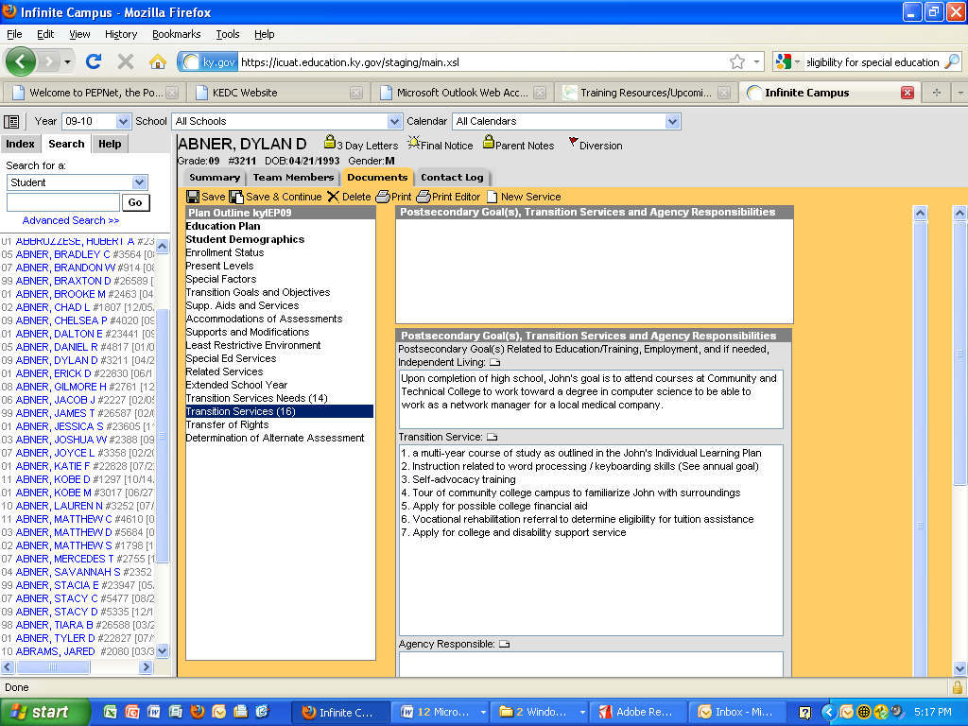

Following are other examples that support the goal of “John’s goal for after graduation is to enroll in courses at the Community and Technical College to prepare for work in the field of medical technology.”

* In the area of Instruction:

* a multi-year course of study as outlined in the John’s Individual

Learning Plan

* Instruction related to word processing / keyboarding skills

* Tutoring (peer or teacher) in reading comprehension strategies

* Self-monitoring instruction related to on-task behavior

* Self-advocacy training

* In the area of Related Services:

* Speech language services to improve expressive communication

* Occupational therapy services to improve handwriting

* In the area of Community Experience:

* Three visits to community college

* Trip to community college bookstore to purchase supplies needed

* Tour of community college campus to familiarize John with surroundings

* In the area of Development of employment and other Postschool Adult Living Objectives:

* Part time employment in a position related to medical technology

* Apply for possible college financial aid

* Vocational rehabilitation referral to determine eligibility for tuition

assistance

* Apply for college and disability support service

Notes:

1. Since the regulation states that transition services include course of study, one transition service that may be listed for every child is providing the course of study as outlined in their ILP/IGP.
2. Notice that examples are given that would cover needs in various areas. The ARC only includes transition services that the student needs from these categories; the ARC doesn’t have to have a service noted in each category if the student doesn’t need it.

Additional examples of transition services in the various areas:

Transition Services in the area of Instruction

The following listed activities/strategies can be a formal or informal imparting of knowledge or skills that a student needs to receive in specific areas to complete needed courses, succeed in the general curriculum and gain needed skills. The activities/strategies can include, but are not limited to, such things as:

* Provide course of study leading to a diploma
* Provide course of study leading to a certificate
* Keep appraised of graduation status and follow-up if issues arise
* Provide opportunities to visit college campuses and meet with student support services (Disability

Services Coordinator)

* Enrollment in a tech-prep program
* Enrollment in a cooperative education course
* Instruction about Section 504 of the Rehabilitation Act and Americans with Disabilities Act
* Provide opportunities to explore admission requirements for possible part-time enrollment at a Vocational/Technical School
* Instruction in the process for accessing apartments for rent
* Provide information on continuing and adult education opportunities
* Self-Advocacy/Self-Awareness instruction
* Enrollment in career and vocational education/vocational English
* Enrollment in occupation specific courses
* Enrollment in an adult living course
* Enrollment in an internship/apprenticeship program
* Provide opportunities in extra curricular activities such as __________
* Enrollment in Adult/Continuing Education courses such as __________
* Enrollment in Community College courses such as __________
* Enrollment in parenting classes
* Instruction in financial management-money skills
* Instruction in time management and organizational skills
* Provide opportunities to practice negotiation skills for job raises, car purchases, etc.
* Provide access to tutoring services in school
* Instruction in writing an information interview letter to the disabilities resource coordinator at a postsecondary school of interest
* Conduct a learning styles inventory to identify preferences and strength modes
* Provide practice in taking a GED pre-test
* Assist in application for a Big Brother/Big Sister to help with homework and mentoring
* Instruction in CPR/First Aid course
* Enrollment in an SAT prep course
* Enrollment in college prep courses; complete ACT/SAT application
* Instruction about community agencies that provide services and support to people with disabilities
* Provide opportunity to tour post school occupational training programs
* Provide assistance in obtaining, completing, and submitting applications to colleges of choice
* Provide opportunities to research college scholarship opportunities
* Provide assistance in obtaining, completing, and submitting applications for tuition assistance programs
* Provide assistance in enrolling in and taking classes through the local County Extension Program
* Apply for and provide for taking modified ACT test
* Instruction and practice self-advocacy
* Instruction about employability skills and schedule a work experience
* Instruction in work readiness skills and vocational English
* Instruction and practice of social skills
* Instruction and practice of communication skills
* Instruction about the decision making process and practice necessary skills
* Instruction in Crisis Management skills
* Enrollment in a driver’s education class
* Instruction and practice in obtaining materials in accessible formats independently (electronic text, large print)
* Instruction and practice in identifying vendors and organizations offering materials in accessible format

Transition Services in the area of Related Services

Activities/strategies in this area should consider the current and projected related service needs of the student. This area of the transition services is not for specifying the needed related services for the next school year. Related services for the coming school year should be addressed in another section of the IEP. Rather, this context of related services has to do with determining if the related service needs will continue beyond school. If so, the IEP should identify who or what agency might provide those services, help identify how the student and parent can access those services and connect the student and parent to whoever will provide those services before the student leaves the school system. This type of planning, discussion, and identification of activities/strategies should help make the move from the school acting as one related service provider to another adult agency or service provider as seamless as possible for students and families.

* Rehabilitation counseling
* Orientation and mobility services
* Develop linkages to adult agencies or providers
* Create a list of people, phone numbers, etc., who can be resources after high school.
* Instruction in how to apply at adult support agencies
* Instruction in how to identify community mental health agencies
* Instruction in how to identify potential post school providers of related services and funding sources
* Instruction in how to identify potential post school providers of recreation therapy or occupational therapy and potential funding sources
* Instruction in how to identify potential post school providers of physical therapy
* Assistance in applying for a mentor through a local, non-profit agency for counseling of substance abuse and delinquency
* Provide practice in conversations using an augmentative communication device
* Provide orientation and mobility training in place of future employment
* Provide opportunities for interviewing a job coach for assistance with learning job tasks
* Instruction in how to identify potential post school providers of speech therapy
* Instruction in identifying city/county transportation options
* Assistance in applying for eligibility with state transportation program
* Assistance in applying for eligibility with the state division of Mental Health Services
* Assistance in applying for Supplemental Security Income (SSI) from the Social Security Administration (SSA)
* Assistance in writing a Plan for Achieving Self-Support (PASS) and submit it to SSA to obtain funding for transportation to and from a job
* Instruction in how to identify possible sources of support for coping with difficult life situations
* Instruction in how to obtain a driving capability assessment from __________
* Instruction in how to interview and select an adult provider
* Instruction in how to identify options for modified transportation
* Conduct an assistive technology evaluation
* Instruction in how to obtain new equipment (wheelchair, seating, braces, Assistive Technology, etc.)
* Instruction in how to obtain audiological services for post school
* Assistance in contacting college/tech school to arrange for class interpreters
* School health and social work services
* Instruction in what accommodations are necessary for after high school
* Prepare to contact college professors within the first week of class to discuss needed accommodations and modifications and arrange for needed materials in alternate format
* Prepare to advertise and hire reader or note-taker for college classes

Transition Services in the area of Community Experiences

The following items emphasize activities/strategies that are generally provided outside the school building and that prepare the student for participation in community life. These activities should encourage the student to participate in community settings that may include community-based work experiences/exploration, job site training, government, social, recreational, leisure, shopping, banking, transportation, and/or other opportunities.

* Instruction about relevant community resources (health care facilities, bank, library, laundry-mat, postal services, church, restaurants, hair salon)
* Provide opportunities for practice in using relevant community resources (health care facilities, bank, library, laundry-mat, postal services, church, restaurants, hair salon)
* Practice making and keeping own appointments
* Teach appropriate social behaviors in the community (tipping, asking for assistance, standing in line, being quiet in relevant situations)
* Provide opportunities for practice in using cost saving techniques (comparison shopping, sale prices, discount stores versus department stores)
* Provide opportunities for practice getting around in the community (using driver’s license/vehicle, public transportation, maps/schedules/asking for directions)
* Develop a realistic plan for addressing post secondary housing needs and demonstrate the ability to secure housing (understands cost of different types of housing, housing contracts, process of relocating)
* Instruction in how to apply for residential services
* Provide opportunities for practice in using purchasing options and pay for large purchases in the community (use of credit cards, loans)
* Instruction in basic insurance needs and where to purchase coverage
* Provide opportunities for practice in finding specified areas with his/her own school and neighborhood
* Teach relevant community signs (Men, Women, Do Not Enter, Danger)
* Provide opportunities for practice accessing services and items which have a constant location (restrooms, classrooms, school, ordering counters, ticket booths, bus stops)
* Provide opportunities for practice selecting and ordering his/her own food in restaurants
* Provide opportunities for practice safely crossing streets including those with traffic lights
* Provide opportunities for practice locating needed items in grocery store
* Teach recognition cost and pay for small purchases in the community
* Teach the dangers of accepting assistance or goods from strangers
* Teach how to respond to emergency situations in the community (missing the bus, contact with strangers, being lost)
* Provide opportunities for practice the ability to identify the locations of and get to social service agencies (employment agencies, rehabilitation services, social services, adult services)
* Provide opportunities for practice banking, budgeting, and shopping skills
* Provide opportunities for practice using public transportation or get a driver’s license
* Provide opportunities for joining local organization or club
* Instruction in how to register to vote and how to vote
* Instruction in ways to use leisure time
* Instruction in how to identify any supports needed to participate in activities
* Teach about banking options: checking, savings, etc.
* Instruction in how to identify specific community facilities to join for recreation/leisure services
* Instruction in how to identify specific recreation/leisure activities of choice and participate independently
* Instruction in how to identify activities of choice to do with family members or friends
* Instruction in how to identify activities of choice to do with a provider
* Instruction in how to identify different living/housing options
* Assistance in obtaining a state identification card or driver’s license
* Instruction in how to register with Selective Service
* Teach skills necessary to participate in the voting process
* Provide opportunities to tour colleges and technical schools
* Provide opportunities for practice arranging private transportation
* Arrange for meeting with Office for the Blind Counselor to review community support services available and to obtain information about state and national organizations

Transition Services in the area of Employment

Activities/strategies listed in this area focus on development of work-related behaviors, job seeking and keeping skills, career exploration, skill training, apprenticeship training, and actual employment.

* Conduct assessments regarding the student’s desired employment and career interests for adult life beyond college and/or postsecondary vocational training
* Assistance in preparing for work towards obtaining a license to become a __________
* Arrange for meeting with adult workers in the career field of __________
* Enrollment in a career awareness program
* Provide a community-based career exploration program
* Provide opportunity to explore possible summer employment through the Summer Youth JTPA program
* Arrange for meeting with supported employment agencies to identify and evaluate their services
* Provide for opportunity to participate in a supported employment job experience
* Instruction about county one-stop career centers
* Provide information and/or apply for youth apprenticeship program
* Arrange for completion of an application for OVR
* Arrange for meeting with an OVR counselor to develop an Individualized Plan for Employment
  + Assist in writing a Plan for Achieving Self-Support (PASS) and submit it to Social Security to obtain funding for starting a business
* Instruction about the voucher for Ticket to Work (for SSI beneficiaries) and interview providers
* Contact the state Office for the Blind to obtain employment services
* Instruction in how to register with Employment Services
* Conduct the ASVAB (Armed Services Vocational Aptitude Battery)
* Provide opportunities for practice completing job applications and interviewing skills
* Provide opportunities for practice explaining disability and needed accommodations
* Provide opportunities to memorize Social Security number
* Provide opportunity to attend transition fair or career fair at school and/or in the community
* Provide opportunities to research through O*Net (www.online.onetcenter.org) careers, qualifications and specifications, and key words for resume development
* Obtain a list of providers to Office of Vocational Rehabilitation who conduct person-centered planning, job development and placement, and job coaching
* Provide practice in writing resume, cover letters, and thank you notes for after interviews
* Provide job shadowing
* Observe job site and develop a task analysis for job activities
* Instruction in how to select clothes for job interviews
* Instruction in factors which influence job retention, dismissal, and promotion
* Provide opportunities for practice in responding appropriately to verbal correction from others
* Provide opportunities for practice in maintaining appropriate work habits when supervisor is not present
* Provide opportunities for practice demonstrating the skills necessary to perform successfully in a job interview
* Instruction in how to complete a job application
* Provide for a variety of successful community-based work experiences
* Provide opportunities to visit possible employment sites
* Instruction in how to access various resources for assistance in job searching: want ads, employment agencies, on-line resources
* Provide opportunities for practice demonstrating the necessary interpersonal skills to work with others (good listening skills, good verbal communication skills)
* Instruction in how to locate and complete information for grants, loans, scholarships
* Arrange meeting with the Office for the Blind counselor to develop an Individual Written Rehabilitation Plan

Transition Services in the area of Post School Living Objectives

Activities/strategies listed in this area emphasize activities/strategies that focus on adult living skills. These are generally activities that are done occasionally such as registering to vote, filing taxes, obtaining a driver’s license, renting or buying a home, accessing medical services, obtaining and filing for insurance, planning for retirement, and accessing adult services such as Social Security Income (SSI).

* Provide for completion of Individual Learning Plan
* Conduct transition assessments regarding the student’s desired residential life beyond high school and a residential postsecondary education setting
* Instruction in how to identify post secondary housing options
* Instruction in how to apply for post secondary housing
* Instruction I how to apply for post secondary educational options
* Instruction in how to apply for financial assistance to access post secondary training/learning options
* Provide information about guardianship issues and estate planning
* Instruction about managing/maintaining/performing simple repairs on a home and obtaining modifications/accommodations
* Instruction in how to open a bank account and manage finances/budgets/bills
* Instruction in how to apply for credit cards and manage personal debt
* Instruction in how to apply for housing assistance (HUD)
* Instruction about consumer skills, rights, and responsibilities
* Instruction in how to join the local YMCA, YWCA, health club, or community recreation center
* Contact the state Office for the Blind to obtain training on independent living

Transition Services in the area of Daily Living Skills

Daily living skills are activities that adults do most every day. These include such things as preparing meals, budgeting, maintaining a residence, paying bills, raising a family, caring for clothing, and/or personal grooming.

* Provide information about community agencies that provide daily living skills training to adults
* Develop a contact list of agencies that provide residential supports in this county
* Provide information about a variety of adult housing options with supports
* Instruction in how to identify possible assistive technology and adaptive assistance
* Enrollment in courses in foods, family life, child development, and life management
* Instruction in how to file taxes
* Enrollment in childcare classes
* Enrollment in cooking class
* Instruction in how to sign up for utilities (gas, water, electric, telephone, cable, etc.)
* Instruction in how to operate a washer and dryer
* Instruction in how to prepare an initial housing budget (down payment, furniture, bath towels, cleansers, utilities, etc.)
* Instruction in how to cost compare for household items (appliances, linens, etc.)
* Instruction in how to manage daily time schedule
* Instruction in how to manage money and pay bills
* Instruction in how to develop a personal fitness routine
* Provide opportunities for practice purchasing food
* Provide opportunities for practice preparing meals
* Provide opportunities for practice purchasing clothing and caring for clothes
* Provide opportunities for practice managing personal self care (dressing/undressing and grooming)
* Instruction in how to communicate personal information (i.e. name, address, gender, telephone number, Soc. Sec. #)
* Instruction in how to dress appropriately for specific situations (i.e. weather, special events, casual, seasonal)
* Provide opportunities for practice choosing and wear clothing appropriate in size, color, and style
* Provide opportunities for practice demonstrating safety precautions (i.e. use of locks, proper use of appliances)
* Instruction in how and when to seek medical assistance
* Provide opportunities for practice demonstrating advanced telephone skills (i.e. long distance, phone card, directory, directory assistance, taking messages, call waiting/forwarding, cell phone)

Transition Services in the area of Functional Vocational Evaluation

A functional vocational evaluation is an assessment process that provides information about job or career interests, aptitudes, and skills. Information is gathered through situational assessments in the setting where the job is performed. This can include observations, formal or informal measures, and should be practical. Information gathered through a functional vocational assessment can be used to refine educational experiences, courses of study, and employment activities/strategies listed in the transition services in the IEP.

* Conduct a functional vocational evaluation
* Maintain a portfolio of observable work samples
* Conduct an interest/aptitude survey
* Conduct ASVAB test
* Teacher and parents/guardians complete an Enderle-Severson Transition Rating Scale/other transition assessment
* Complete non-verbal picture career interest inventory
* Complete application to OVR

*These examples are adapted from a combination of works by Dr. Ed O’Leary, Wendy Collison and CESA 7 and was (January, 2009). Information included was taken from Transition Requirements – A Guide for States, Districts, Schools, Universities and Families, collaboratively developed by Jane Storms, Ed O’Leary and Jane Williams, May, 2000.*

**Items 49c and d**

**49c**

**Look for**: Notice of ARC Meeting.

**Directions:**

* Mark “YES” if the Notice of ARC Meeting indicates an outside agency that is likely to be responsible for providing or paying for transition services that are needed to assist the child in reaching postsecondary goals was invited to the meeting.
* Mark “YES” if the ARC documented that the need for an outside agency was not appropriate or the child’s IEP did not include transition services that required another agency.

**Note**: Outside agencies may include Office of Vocational Rehabilitation; Commission for Children with Special Health Care Needs; Department of Mental Health.

**49d**

**Look for**: Consent for Outside Agency Invitation.

**Directions**:

* Mark “YES” if documentation includes a signed, dated parent(s) (or emancipated youth) Consent for Outside Agency Invitation obtained prior to the Notice of Admissions and Release Committee Meeting, if a representative of an outside agency that is likely to be responsible for providing or paying for transition services is invited to the ARC meeting.
* Mark “YES” if Item 49c indicates that the ARC documented need for other agency was not appropriate or child’s IEP did not include transition services that required another agency.

|  |  |  |
| --- | --- | --- |
|  | **Yes** | **No** |
| 51c. For transition services likely to be provided or paid for by another agency, the other agency is invited to send a representative, if appropriate. |  |  |
| 51d. If an agency was invited to send a representative, signed Consent for Outside Agency Invitation is included. |  |  |

**Examples and Documentation on the IEP Form and**

**Notice of ARC Meeting**

49c. For transition services likely to be provided or paid for by another agency, the other agency is invited to send a representative, if appropriate.

* If the IEP includes transition services that may be provided or paid for by another public agency, then the ARC documents that agency as the “Agency Responsible” in the section titled “Agency Responsible” on the transition page of the IEP. *This documents the need to invite a representative from that agency to an ARC meeting.* The ARC then invites that agency’s representative to an ARC meeting to discuss transition services. Let’s look at John’s transition services as examples.

Examples:



To document in Infinite Campus, use the 16+ IEP, go to the “Transition Services (16)” editor. Type the transition services under the heading “Agency Responsible.”

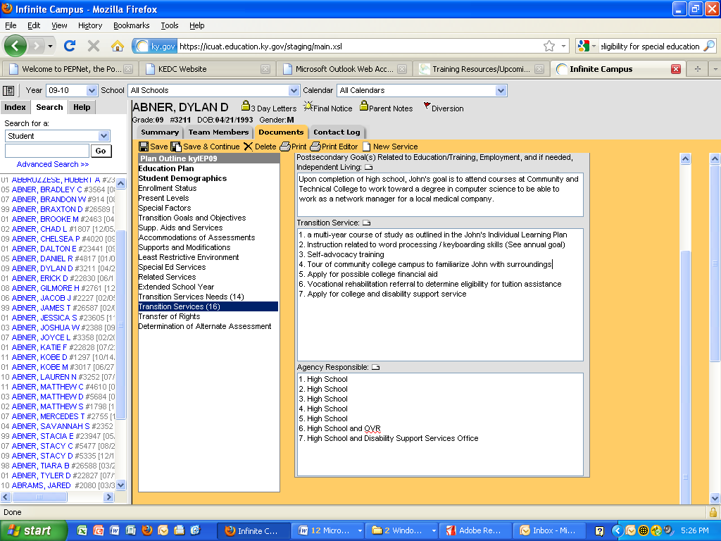

Notes:

1. Notice that for the first five (5) transition services, only the high school is listed as the agency responsible. No outside agency is needed to provide or pay for these services. For the last two (2) transition services listed, another agency is listed. For these services, the two agencies, OVR and the Community and Technical College’s Disability Support Services Office would need to be invited.
2. Sometimes, an ARC plans to do these types of service during the student’s senior year. In that case, the ARC might document the service as “Vocational rehabilitation referral to determine eligibility for tuition assistance during senior year” or “Apply for college and disability support service during senior year.” This shows that the ARC won’t be inviting another agency until the student’s senior ARC meeting.
3. There are many possible transition services that a student may need and a variety of outside agencies that may provide or pay for those services. The ARC should seriously consider the assistance of outside agencies and plan accordingly.

* If an outside agency is to be invited, the ARC documents this on that meeting’s Notice of Admissions and Release Committee Meeting. As in John’s case, two agencies will be invited.

Example:

|  |  |  |  |
| --- | --- | --- | --- |
| Other (Specify): Disability Support  Services Office   |  |  |  | | --- | --- | --- | |  |  |  | |

* If no outside agency is listed for any transition service on a student’s IEP, the ARC should mark “Not Appropriate at this time” on the Notice of Admissions and Release Committee meeting.

|  |
| --- |
|  |

* *It is also strongly recommended that the ARC discuss the need for outside agencies and record that discussion in the Conference Summary/Action Notice.* It must be clear what actions the ARC is or is not taking regarding the need for outside agencies.

49d. If an agency was invited to send a representative, signed Consent for Release of Information is included.

Look back at the examples for 49c of how to document the need to invite another agency and the actual invitation to that agency.

Notice that the recommended agency is for the individual student’s needs. It aligns with the transition services and agency responsible on the student’s IEP. The consent must not be a “blanket” consent for many agencies “just in case you need them.” **IDEA requires that consent be informed, which means that the parent or emancipated youth must be informed as to which agencies are invited**. The particular agency or agencies that are invited are determined by the transition services that are needed.

Example:

**CONSENT FOR OUTSIDE AGENCY INVITATION**



In your resource documents, you should have a full version of a sample form to use for the purpose of getting consent from the parent or eligible student to invite an outside transition agency to discuss transition needs/services. If the ARC then needs a release of records from the parent or eligible student, the district’s basic Third Party Release of Records form could be used. Once signed and dated by the parent or emancipated student, the consent is valid until the student graduates or revocation of the consent takes place, unless the district’s Policies and Procedures require Consent be obtained annually.

Note: The ARC documents if no outside agency is needed at a particular meeting. If no outside agency is listed for any transition service and the Notice of Admissions and Release Committee Meeting documents that another agency is “Not Appropriate at this time,” then the Consent to Invite Transition Agency / Release of Information is not required.

**Item 49e**

**Look for**: Individual Learning (Graduation) Plan, multi-year course of study.

**Directions:**

* Mark “YES” if documentation includes at least one of the following: a) ARC Conference Summary notes of the discussion of the ILP (IGP) with each course in course of study listed; b) a copy of the ILP (IGP); or c) a copy of child’s multi-year course of study.

**Note**: Multi-year means from the current year to the child’s expected year of exiting high school.

|  |  |  |
| --- | --- | --- |
|  | **Yes** | **No** |
| 49e. As a transition service, the child has a multi-year course of study as outlined in the Individual Learning (Graduation) Plan. |  |  |

|  |
| --- |
| Comments: |

**Examples and Documentation on IEP Form and Course of Study**

49e. As a transition service, the child has a multi-year course of study as outlined in the Individual Learning (Graduation) Plan.

* The ARC uses the IEP form section, “Transition Service Needs” to document the ARC’s consideration of the student’s course of study when developing the IEP transition components. This requirement is for IEPs of students in the 8th grade or age 14, *whichever comes first*. See example below.

|  |
| --- |
| **Transition Services Needs** (Beginning in the child’s 8th grade year or when the child has reached  the age of 14 and thereafter) |
| **Does the student’s Individual Learning Plan (ILP) include the student’s course of study?**  No. If **No**, do not proceed with development of IEP until ILP is initiated, including the child’s course of study.  Yes. (See student’s attached course of study to include current year through graduation or exiting special  education)  **Do transition service needs focus on the child’s course of study and are they addressed in the Present Levels?**  No.  Yes. |

This documentation shows that the ARC considered the student’s ILP course of study (education plan) and used it to develop the Present Levels’ Transition Needs statement.

* + Secondly, the ARC includes a copy of the student’s multi-year course of study in the due process record. This can be documented in at least two different ways.
    1. One is for the ARC to print out a copy of the student’s course of study from the Individual Learning Plan (ILP). The ILP calls the course of study “education plan.” *Be sure that the student has entered courses for all years up until exit year.*
    2. Another way to document course of study is for the ARC to use a district form to outline the student’s course of study.

Some districts do both, allowing the ARC to talk with the student regarding courses completed and courses needed with the district form that he/she may later use to update the online ILP. Either way, the important thing is for the course of study to be there and for it to cover courses from the current year to the student’s exit year.

An example of one district’s course of study form is in the documents posted on Transition One Stop under Training Resources – Web Based Training Materials for Indicator 13 (Secondary Transition) - Additional Resources.

* + It is also strongly recommended that the ARC include documentation of their discussion of the multi-year course of study in the Conference Summary/Action Notice.

Example of a copy of the student’s course of study from the ILP:

**Education Plan____________________________________________________**

Grade 9

English I

Physical Education

Social Studies I

Science I

Algebra I

Life Skills

Health Science Introduction

Grade 10

English II

Arts and Humanities

Social Studies II

Science II

Algebra II

HS Anatomy and Physiology

Grade 11

English III

Social Studies III

Science III

Geometry

Medical Terminology

Grade 12

English IV

Medical Math

Career and Family

Child Development

Medical Technology

Note: A point to remember is that the definition of course of study includes the clarification that *the course of study is designed to achieve the student’s postsecondary goals*.

**Item 49f**

**Look for**: IEP, Annual Goals or Transition Page, or Conference Summary/Action Notice form.

**Directions:**

* Mark “YES” if, for at least one annual goal, the ARC documents which postsecondary goal the annual goal supports OR the annual goals that support postsecondary goals are listed as transition services on the transition page of the IEP.

|  |  |  |
| --- | --- | --- |
|  | **Yes** | **No** |
| 49f. Annual goal(s) included in the IEP are related to the transition service needs. |  |  |

**Examples and Documentation on IEP Form**

49f. Annual goal(s) included in the IEP are related to the transition service needs.

* On the IEP form, there is a particular place to document that an annual goal supports the student’s postsecondary goal(s)—on the annual goal page, just under the “Specially Designed Instruction” section.
* The ARC may also document linkages between the annual goals and the postsecondary goals on the transition page of the IEP as shown in the example below.

Example:



To document in Infinite Campus, use the 16+ IEP, go to the “Transition Goals and Objectives” editor. Check the box next to the postsecondary goal(s) to which the annual goal is linked.

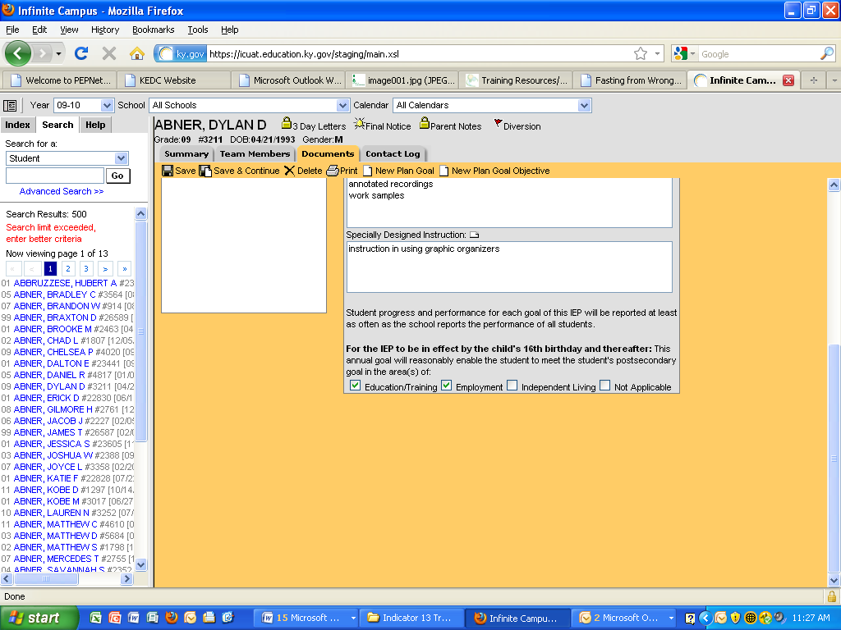

Notes:

* 1. Notice that this annual goal supports the postsecondary goal for training/education and employment, which is okay.
  2. The second example shows an annual goal that the ARC documents supporting only the employment goal.
  3. One thing to remember is that the ARC wouldn’t check that an annual goal supports an independent living postsecondary goal if the student doesn’t even have an independent living postsecondary goal.

**Item 49g**

**Look for**: IEP, Transition Assessments, or Conference Summary/Action Notice form, Description of each Evaluation Procedure, Test, Record, or Report used as a Basis for the ARC Decision.

**Note**: Actual copies of the transition assessments administered may be maintained as other components of the child’s education record (e.g., ILP career assessments, learning style inventories).

**Directions:**

* Mark “YES” if, documentation includes evidence that postsecondary goals are based on formal and/or informal transition assessment.

**Note**: Assessments may include: behavioral assessment information, aptitude tests, interest and work values inventories, intelligence tests and achievement tests, personality or preference tests, career maturity or readiness tests, self-determination assessments, work-related temperament scales, and transition planning inventories.

**Note**: Age-appropriate means the measure reflects the child’s chronological age rather than developmental age.

|  |  |  |
| --- | --- | --- |
|  | **Yes** | **No** |
| 49g. Measurable postsecondary goals are based on age appropriate transition assessment. |  |  |

**Examples and Documentation on IEP Form**

49g. Measurable postsecondary goals are based on age appropriate transition

assessment.

* On the IEP form’s transition page, there is a particular place to document that the transition assessments used as a basis for determining the postsecondary goal(s). The section is titled “What transition assessments were used to determine the child’s preferences and interests?” Let’s look at an example for John.



To document in Infinite Campus, use the 16+ IEP, go to the “Transition Services Needs” editor. Check the box next to the transition assessments used to determine the student’s postsecondary goal(s).

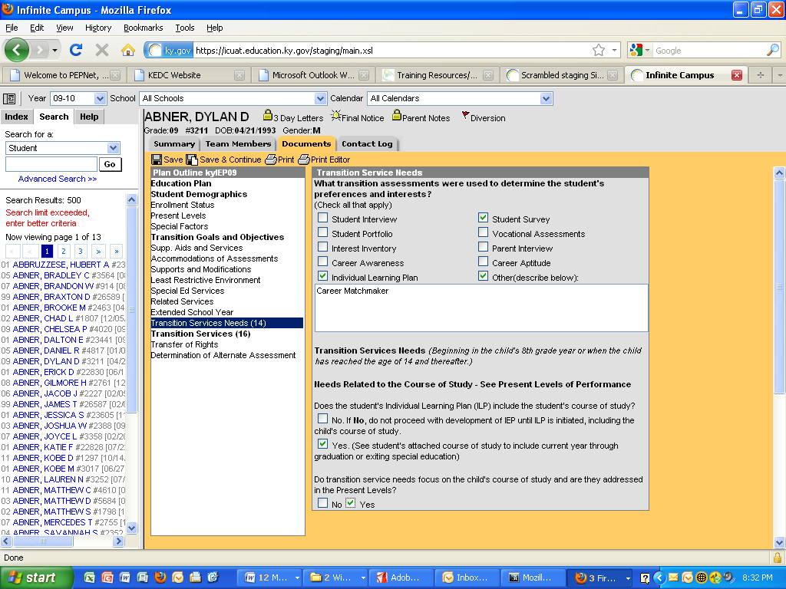

Note: The ARC also uses the information gathered from the transition assessments to develop the Present Levels’ (PLEP) Transition Needs statement, as well as determine the postsecondary goal(s). When the ARC references particular transition assessments in the Present Levels’ Transition Needs statement, this documents their use and consideration of the transition assessment data. As with any ARC discussion, it is also recommended that the ARC document their discussion in the Conference Summary/Action Notice.

**Item 49h**

**Look for**: Notice of ARC Meeting

**Directions:**

* Mark “YES” if the child is listed as invited to attend the meeting on the parent’s Notice of ARC Meeting.

|  |  |  |
| --- | --- | --- |
|  | **Yes** | **No** |
| 49h. The child is invited to the ARC meeting where transition services were discussed. |  |  |

**Examples and Documentation on Notice of ARC Meeting**

49h. The child is invited to the ARC meeting where transition services are discussed.

* On the Notice of ARC Meeting, mark the student as an invited member. Here’s an example.

|  |
| --- |
|  |

Note: In addition to the child being listed as invited to the ARC on the parent’s Notice of ARC Meeting, the record should also show the student’s signature on the conference summary as attending the ARC meeting. If the student does not attend, the ARC must document other steps that were taken to ensure that the student’s interests and preferences were considered. This may include documentation of surveys, interviews, ILP/IGP, description in the conference summary notes, etc.

**Item 49i**

**Look for**: IEP

**Directions**:

* Mark “YES” if the IEP has been reviewed annually and includes postsecondary goals.

|  |  |  |
| --- | --- | --- |
|  | **Yes** | **No** |
| 49i. The measurable postsecondary goals are updated annually. |  |  |

**Examples and Documentation on IEP Form**

49i. The measurable postsecondary goals are updated annually.

* The ARC should document annual review of the IEP, including the postsecondary goals, by stating the meeting date and the anticipated review date of the IEP. By checking the last IEP date against the current IEP date, the annual timeline may be confirmed.



To complete the requirement for 49i, the IEP must also include postsecondary goals.



Note: Just as the student’s Individual Learning Plan (or Individual Graduation Plan) is updated annually to reflect changes in education/training and employment goals, so must the student’s postsecondary goals in the IEP be updated. The ARC must review transition assessment data and determine if more information is needed as a basis for developing new or revising postsecondary goals.

**Item 49 (Summary of 49a-49i)**

**Look for**: Summary of the Record Review items for 49 (a) - (i)

**Directions:**

* Mark “YES” if all the requirements listed above in (a) – (i) are marked “Yes”
* Mark “NO” if one or more of the requirements listed above is “No”
* Mark “NA” if the child is not yet 16 as of the date of this record review. Skip to #51.

|  |  |  |  |
| --- | --- | --- | --- |
|  | **Yes** | **No** | **NA** |
| 49. **For students who have reached the age of 16 and older, all the Item 49 (a-i) requirements are met:** |  |  |  |

**Item 50**

**Look for**: IEP

**Directions**:

* Mark “YES” if the student is age 16 and all requirements of item 49 are met.
* Mark “NA” if the child is not yet 16 as of the date of this record review. Skip to #51.

|  |  |  |  |
| --- | --- | --- | --- |
|  | **Yes** | **No** | **NA** |
| 50. By the student’s 16th birthday, all of the requirements above are met. (*Mark this item “NA” if the student is 17 or older).* |  |  |  |