Study Guide Unit 1: Ratios and Proportional Relationships
Vocabulary to know:
- Unit rate: ________________________________________________

- Proportion: _______________________________________________

- Equivalent ratios: __________________________________________

- Coordinate Plane: __________________________________________

- Origin: __________________________________________________

- Constant of proportionality: ____________________________________

- Proportional relationships: _____________________________________

- Non-proportional relationships: ________________________________

- Ratio: ___________________________________________________

Standard: 7.RP.2A
Determine whether the table and graph below are proportional.

- Table
Hours | 1 | 2 | 3 | 4
Pay | 12 | 24 | 36 | 48

- Graph
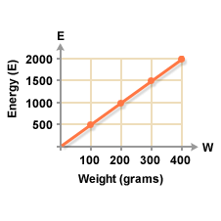

Standard: 7.RP.2B
Determine the constant of proportionality.
Hours(h) | Miles(m)
2 | 140
4 | 280
6 | 420
Tickets(t) | Cost(c)
5 | 60
10 | 120
15 | 180
2.
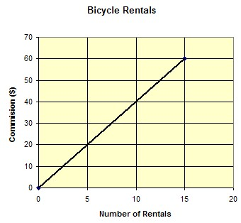
1.
3.
Standard: 7.RP.2C

Write an equation to represent each situation below.
- 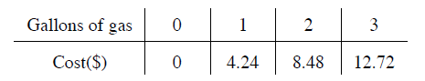

- An elm tree grows 8 inches each year.

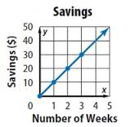

Standard: 7.RP.2D

- What does the ordered pair, (200, 1400) mean on the graph to the right?
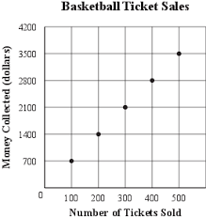

- Identify the unit rate and describe what it means.

- What does the ordered pair, (500, 3500) means on the graph to the right?

